1. Sources Code

MatakuliahValidation.php🡪controller

2. URL

<http://localhost/pustaka_ajeng/index.php/MatakuliahValidation>

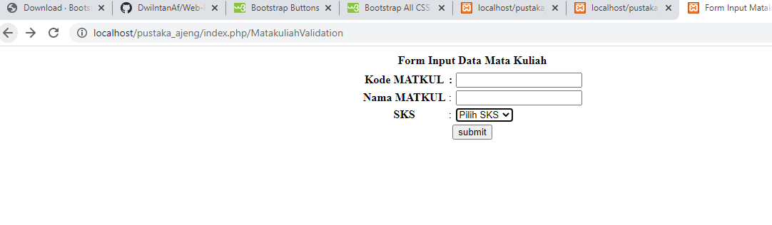3. Capture Output Program